ELECTROMAGNETIC INDUCTION

DEFINITION OF ELECTROMAGNETIC INDUCTION (EMI)
- Electromagnetic Induction is the process of generating an electromotive force (EMF) and subsequently a current in a conductor by changing the magnetic environment or magnetic flux linked with that conductor.
- It is essentially the reverse of the phenomenon where current-carrying wires produce magnetic fields. In EMI, we manipulate magnetic fields to obtain electricity.

PHYSICAL MEANING AND OBSERVATIONS
- Initially, experiments showed that simply placing a loop in a static magnetic field does not produce current.
- Current is only observed when there is a change in the magnetic field (B), the area of the loop (A), or the orientation (θ) of the loop relative to the field.
- The teacher refers to this as the "Raita" (mess) of multiple variables which are ultimately combined into a single physical quantity called Magnetic Flux (ϕ) to simplify the theory.

INTUITION AND CONCEPTUAL UNDERSTANDING
THE SYMMETRY MENTAL MODEL
If a flow of charge (current) creates a magnetic field, then a "flow" or change in a magnetic field should create a flow of charge. Nature loves symmetry.
PLAYFUL MANIPULATION ANALOGY
Think of the magnetic field as a medium. To get a current, you cannot just sit still in the medium; you must "disturb" it. This disturbance can be done by:
1. Shaking the field (Changing B).
2. Reshaping the container (Changing Area A).
3. Twisting the container (Changing Angle θ).

CONCEPT CONNECTIONS
LINK TO ELECTROSTATICS:
Magnetic Flux (ϕᵦ) is mathematically analogous to Electric Flux (ϕₑ = E·A). Both represent the "count" of field lines passing through a surface.
LINK TO MAGNETISM:
EMI bridges the gap between Magnetism (B-fields) and Current Electricity (I). It shows that these are not separate chapters but interconnected behaviors of electromagnetism.

PROBLEM-SOLVING FRAMEWORK
QUESTION TYPE | IDENTIFICATION CLUES | APPROACH / STRATEGY
Detection of Current | Magnet moving toward/away | Check if flux through the loop is changing. No change = No current.
Flux Calculation | Loop in non-uniform field | Use integration: ϕ = Integral of B·dA.
Rotation Problems | Loop spinning at ω | Use θ = ω·t; calculate dϕ/dt.

JEE ADVANCED INSIGHTS
THE EMF WITHOUT CURRENT TRAP:
- Induced EMF can exist in a vacuum, a wooden loop, or a broken wire. However, induced current requires a closed path with finite resistance.
- EMF is a property of the space/region where flux is changing, while current is a property of the conductor placed in that space.

EXPERIMENTAL SUMMARY TABLE:
+--------------------------+--------------+------------------+
| ACTION | FLUX CHANGE? | INDUCED CURRENT? |
+--------------------------+--------------+------------------+
| Move loop in uniform B | No | No |
| Move loop into/out of B | Yes | Yes |
| Rotate loop in B | Yes | Yes |
| Expand/Contract loop | Yes | Yes |
| Change B-field magnitude | Yes | Yes |
+--------------------------+--------------+------------------+

LAST-MINUTE REVISION POINTS:
- Induced EMF is proportional to the rate of change of flux, not the flux itself.
- If the loop is made of an insulator (wood/plastic), EMF is still induced, but current is zero.
- The "effective area" is only the portion of the loop actually submerged in the magnetic field.

--------------------------------------------------------------------------------

DEFINITION OF MAGNETIC FLUX (ϕᵦ)
- Magnetic flux is a scalar physical quantity that represents the total number of magnetic field lines passing through a specific area.
- It is the dot product of the magnetic field vector and the area vector.
- Physical Meaning: It indicates how much magnetic field "pierces" a surface.
- Unit: Weber (Wb) or Tesla-meter² (T.m²).
- Dimensions: [ML²T⁻²A⁻¹].

AREA VECTOR (A)
- The direction of the Area Vector is always perpendicular (normal) to the plane of the loop.

UNIFORM VS. NON-UNIFORM FIELDS
- Uniform Field: If the magnetic field B is constant in magnitude and direction across the entire area, it is taken out of the integral.
Calculation: ϕᵦ = B⋅A = BA cos θ.
- Non-uniform Field: if the magnetic field B varies at different points of the area (e.g., near a straight current-carrying wire), integration is required.
Calculation: dϕᵦ = B⋅dA, and total flux ϕᵦ = ∫B⋅dA

INTUITION AND CONCEPTUAL UNDERSTANDING

THE WINDOW ANALOGY
Think of magnetic field lines as rain and the loop as a window. Flux is the "count" of raindrops passing through the window.
If you tilt the window (change θ), the amount of rain passing through changes.
If you increase the window size (Area A) or the intensity of rain (Field B), the count (Flux) increases.

THE RAITA (MESS) ANALOGY
The teacher explains that B, A, and θ are individual "ingredients" spread out.
Magnetic Flux is the "bowl" that collects these ingredients into one single physical quantity to make studying induction easier.

FORMULA SHEET
+-------------------------+------------------------+---------------------------+
| QUANTITY | FORMULA | CONDITIONS |
+-------------------------+------------------------+---------------------------+
| Magnetic Flux (General) | ϕᵦ = ∫B⋅dA | Non-uniform fields |
| Magnetic Flux (Uniform) | ϕᵦ = BA cos θ | Constant B across area |
| Angle (θ) |θ = Angle(B,Area Vector)| Always measure from normal|
| Magnetic Field of Wire | B = μ₀I / (2πx) | Used for integration |
+-------------------------+------------------------+---------------------------+
JEE ADVANCED INSIGHTS

THE SHARED FLUX PRINCIPLE
If a ring of radius r is inside a square of side L, and the magnetic field only exists inside the ring then the number of field lines crossing the ring is identical to the number of lines crossing the square.

VECTOR INTEGRATION
In advanced problems where both B and the angle θ vary across the surface, you must use the full vector integration: ϕ = ∫(B_x dA_x + B_y dA_y + B_z dA_z).

ALSO :)
While electric flux through a closed surface depends on enclosed charge, the total magnetic flux through any closed surface is always zero because magnetic monopoles do not exist.

HIGH-YIELD REVISION SHEET
MUST REMEMBER
1. ϕᵦ = BA cos θ (Scalar).
2. Area Vector is perpendicular to the loop plane.
3. μ₀/4π = 10⁻⁷.
4. Integral of 1/x is ln(x).

LAST-MINUTE REVISION POINTS
- Magnetic flux depends on three factors: B, A, and the angle θ.
- If a loop is made of an insulator (wood/plastic), flux and EMF still exist, but current is zero.
- For concentric loops, the flux through the outer loop is equal to the flux through the inner field-occupied region.
- Always check if the magnetic field is uniform before using BA cos θ; if not, use integration.
--------------------------------------------------------------------------------

FARADAY AND LENZ LAW

FARADAY'S LAWS OF ELECTROMAGNETIC INDUCTION
Statement: Whenever magnetic flux changes through an area w.r.t. time, an emf is induced. Magnitude of the induced emf in area is equal to the rate of change of magnetic flux through that area.
Mathematical Form: emf = dϕ/dt, I_induced = V/R.
- If the coil has N turns, the total EMF is: e = N(dϕ/dt).
Physical Meaning: EMF is produced even in the absence of a material conductor (like in a vacuum or wood), but induced current only flows if a closed conducting path is provided.

LENZ'S LAW
Lenz's Law defines the direction of the induced EMF or current.
Statement: The direction of the induced current is such that it opposes the change in magnetic flux that produced it.
[ # agar flux increase kar raha h toh current us direction(clockwise or anti-clockwise) m flow karega jaha se flux ghate and vice-versa. ]

Energy Conservation: Lenz's Law is a specific manifestation of the Principle of Conservation of Energy. Mechanical work done in moving a magnet against magnetic opposition is converted into electrical energy.
Mathematical Representation: e = -dϕ/dt (The negative sign represents the opposition described by Lenz).

INTUITION AND CONCEPTUAL UNDERSTANDING
To simplify direction problems, use the simple rule:
1. If flux is increasing: The loop will try to decrease it (Oppose).
2. If flux is decreasing: The loop will try to increase it (Support).

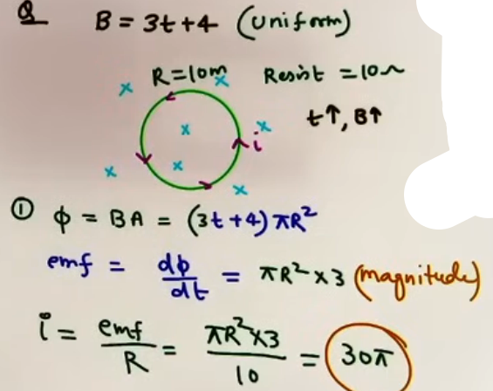
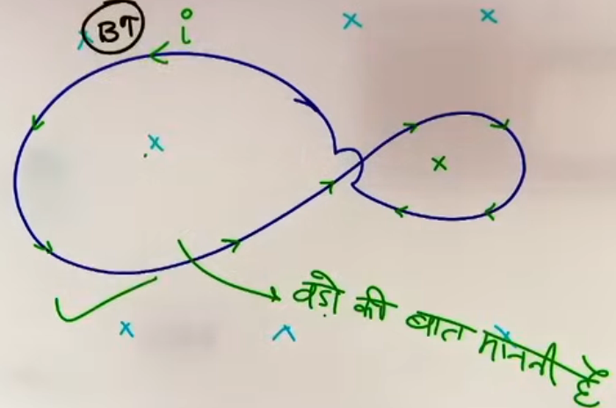
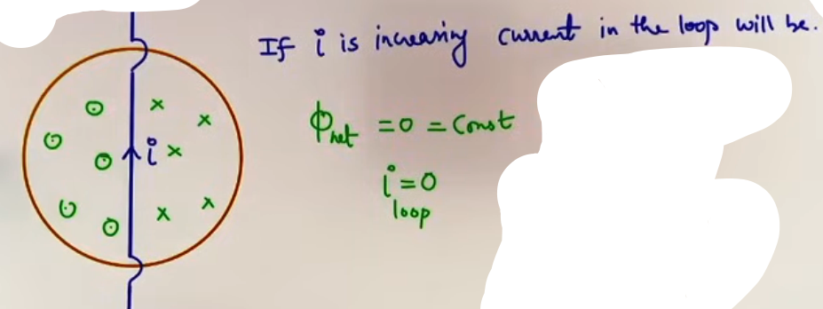
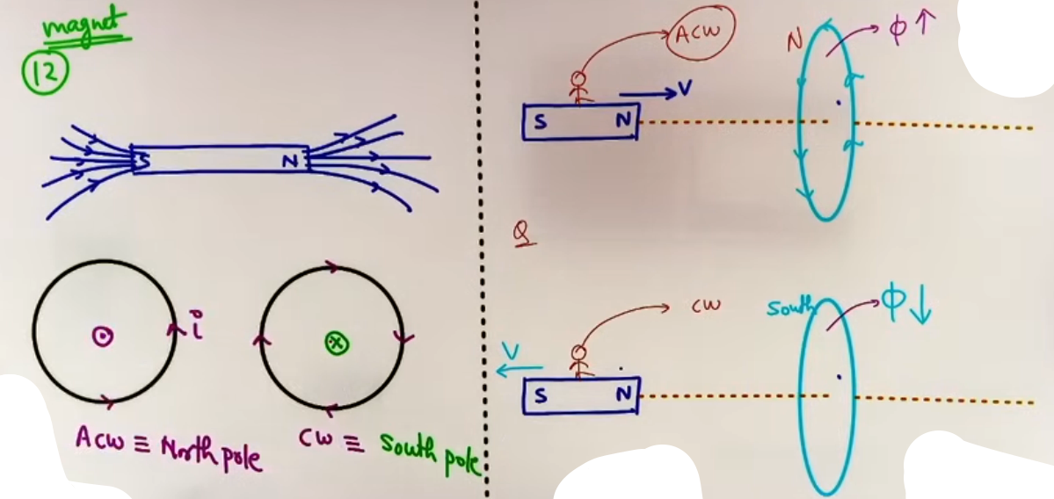ACW matlab Anti-clockwise aur CW matlab clockwise

# current to dono m same hi flow karega toh jiska area jyada hoga vo hi flux ko change kar payega kyuki dono opposite kaam kar rahe h.

FORMULA SHEET
+------------+------------------+----------------------+
| Formula | Condition | Notes |
+------------+------------------+----------------------+
| e = -dϕ/dt | Faraday's Law | Rate of flux change |
| i = e / R | Induced Current | Requires closed loop |
| q = Δϕ / R | Induced Charge | Independent of time |
| P = e² / R | Power Dissipated | Thermal energy loss |
+------------+------------------+----------------------+

CONCEPT CONNECTIONS
CONSERVATION OF ENERGY
The work you do to push a magnet toward a loop is exactly equal to the electrical energy (and eventually heat) generated in the loop. If it supported the change instead of opposing it, you would get "free energy," which violates physics laws.

PROBLEM-SOLVING FRAMEWORK
QUESTION TYPE | IDENTIFICATION CLUES | APPROACH / STRATEGY
Direction of Current | Moving Magnet/Loop | Use "Increase-Decrease" rule.
Magnet Falling | Magnet dropped through ring | Acceleration is always less than g.
Concentric Loops | Two loops, different sizes | Use "Elder's Rule / Bade bhaiya": The larger area dominates.
Insulator Loop | Wooden or Plastic ring | EMF is induced, but current is zero.

EXAMPLES AND APPLICATIONS
EXAMPLE 1: MAGNET FALLING THROUGH A CONDUCTING RING
When a North pole approaches a ring from above, the flux increases downward. The ring creates an upward North pole to repel it. As it falls through and leaves, the South pole is receding; the ring creates a North pole on the bottom to attract it back.
Takeaway: In both cases, the magnetic force is upward, opposing gravity.
Thus, a < g.

JEE ADVANCED INSIGHTS
EMF VS. CURRENT
EMF is a property of the space/region where flux is changing. Even if the loop is made of wood or has a break, EMF is still induced. Current, however, is a material response that requires charge carriers and a complete path.

VELOCITY AND FORCE
The opposing force in Lenz's law often depends on velocity (F proportional to v). This leads to the concept of terminal velocity in electromagnetic induction, similar to fluid mechanics.

COMMON MISTAKES AND TRAPS
MISTAKE | WHY STUDENTS MAKE IT | CORRECT APPROACH / THINKING
Static Flux Error | Thinking high flux = high EMF | EMF depends on dϕ/dt, not ϕ. A stationary 1000T field induces 0 EMF.
Area Vector Angle | Using angle with surface | Always use the angle between B and the NORMAL to the surface.
Insulator Trap | Thinking wood has no induction | EMF is induced in insulators, just no current flows.
Sign Confusion | Getting lost in -dϕ/dt | Solve for magnitude first, then use Lenz's Law separately for direction.

HIGH-YIELD REVISION SHEET
MUST REMEMBER:
1. e = -dϕ/dt.
2. Lenz's Law = Conservation of Energy.
3. Magnet falling through ring: a < g always.
4. Induced current direction: Oppose the change.
5. Induced charge: Delta ϕ / R (Time independent).

LAST-MINUTE REVISION POINTS:
- If a magnet falls through a "broken" ring, a = g because no current can flow to create a counter-magnetic field.
- Induced electric fields (caused by dB/dt) are non-conservative and form closed loops.
- Always prioritize the "Bigger" loop in multi-loop problems.

--------------------------------------------------------------------------------
DYNAMICS OF RODS ON RAILS
- When a rod moves on conducting rails connected to a resistor (R), a closed loop is formed, and an induced current (i) flows.
- Magnetic Force: The induced current experiences a magnetic force F = IlB in the direction opposite to velocity (Lenz's Law).
- Terminal Velocity: If a rod falls under gravity or is pulled by a constant force, it eventually reaches a constant speed when the upward magnetic force equals the downward gravitational force (mg = IlB).
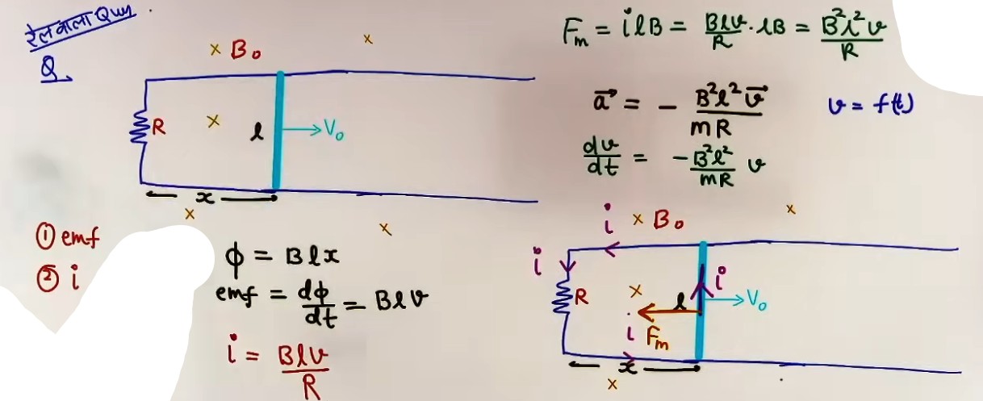
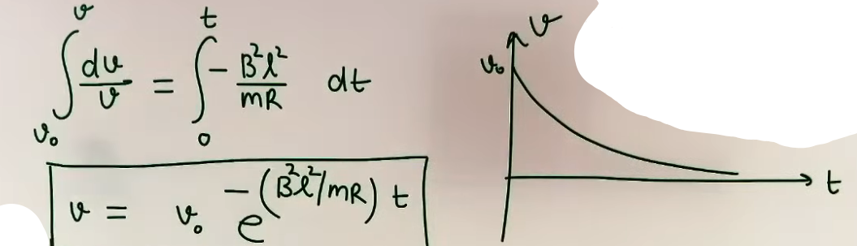
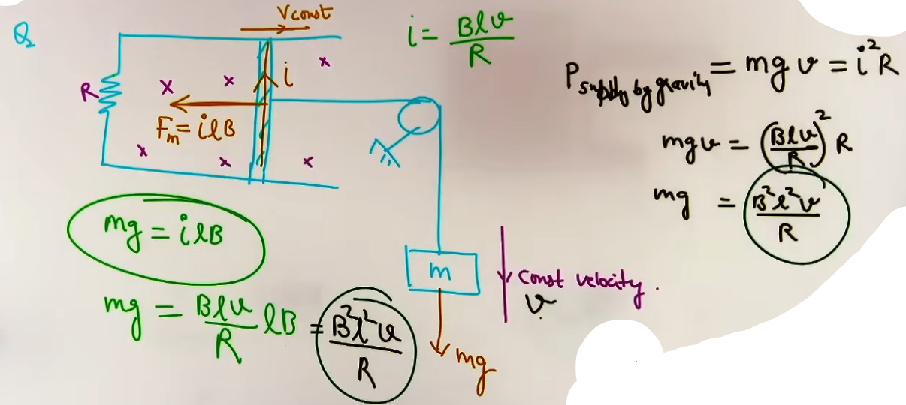
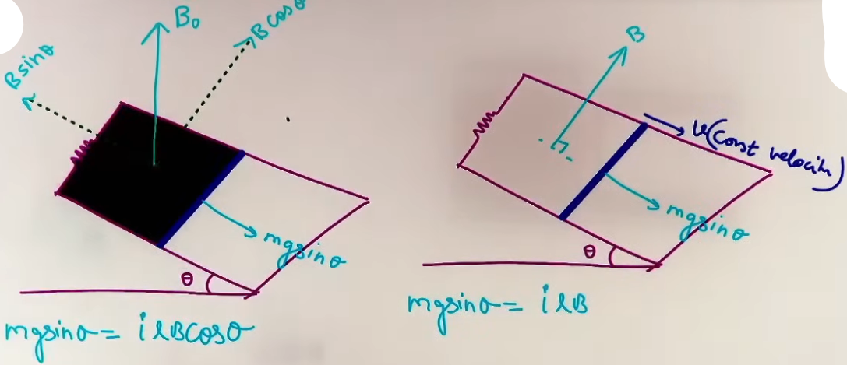
MOTIONAL EMF

TRANSLATIONAL MOTIONAL EMF
- When a conducting rod moves through a magnetic field, it acts like a battery. - This phenomenon is caused by the Lorentz force acting on the free electrons within the conductor.
- Lorentz Force: As the rod moves with velocity v in magnetic field B, electrons experience a force F = q(v x B).
- Charge Separation: Electrons accumulate at one end of the rod, leaving the other end positively charged. This separation creates an internal electric field (E).
- Equilibrium: The separation continues until the electric force (qE) perfectly balances the magnetic force (qvB). At this steady state, the potential difference (EMF) is established.
- Standard Formula: e = BvL (valid when v, B, and L are mutually perpendicular).
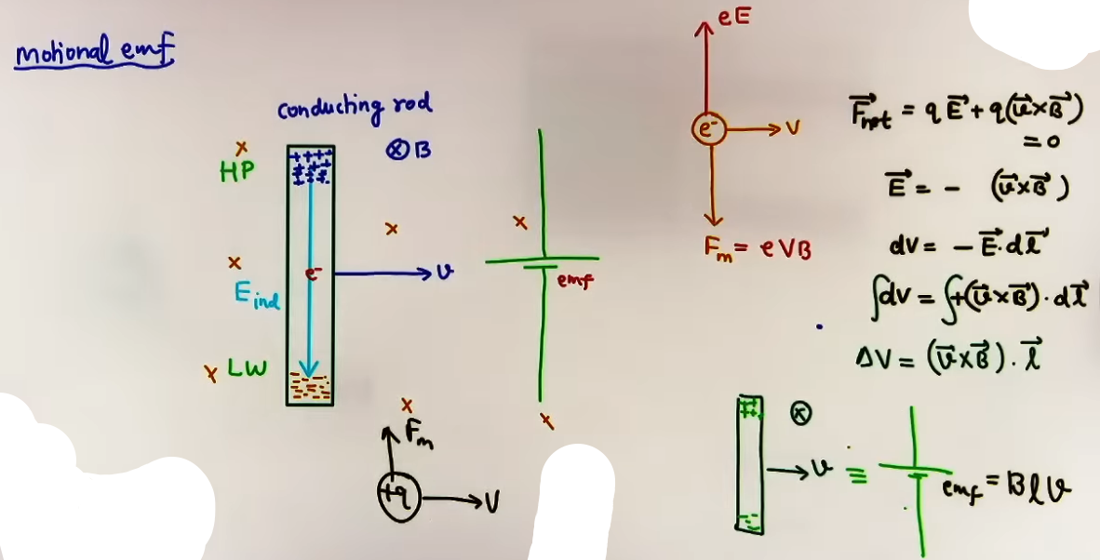
EFFECTIVE LENGTH (Leff)
In a uniform magnetic field, the shape of the wire does not matter for the magnitude of induced EMF. Only the "displacement vector" between the two endpoints of the wire is used for calculation.
Physical meaning: A curved wire is equivalent to a straight wire connecting its start and end points.
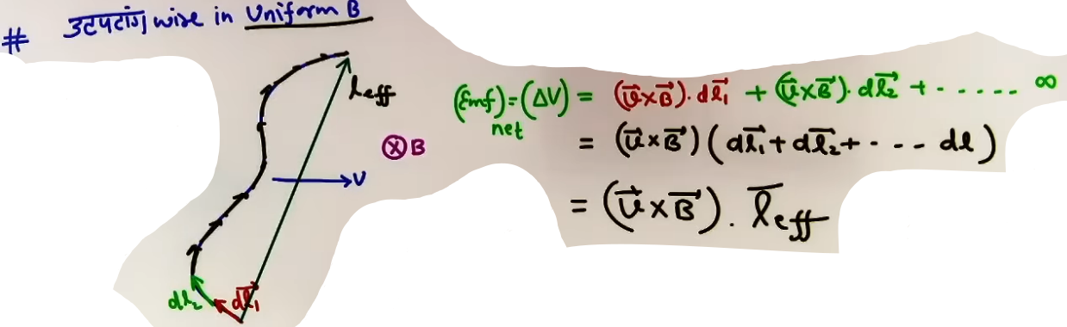
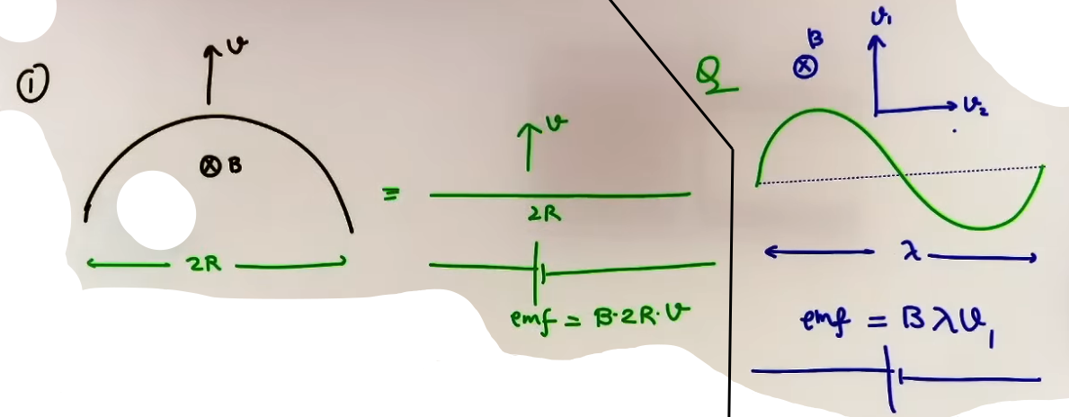

ROTATIONAL MOTIONAL EMF
When a rod of length L rotates about one end with angular velocity ω (ω), different parts of the rod move at different linear speeds (v = xω).
Integration: By integrating the small EMF (dε = Bv dx) from x = 0 to x = L, we find the total potential difference.
Standard Formula: e = 1/2 BωL².

AC GENERATOR PRINCIPLE
A coil with N turns and area A rotating in a uniform magnetic field B at constant angular speed ω (ω) produces a sinusoidal EMF.
Nawab Formula: e = NωAB sin(ωt).
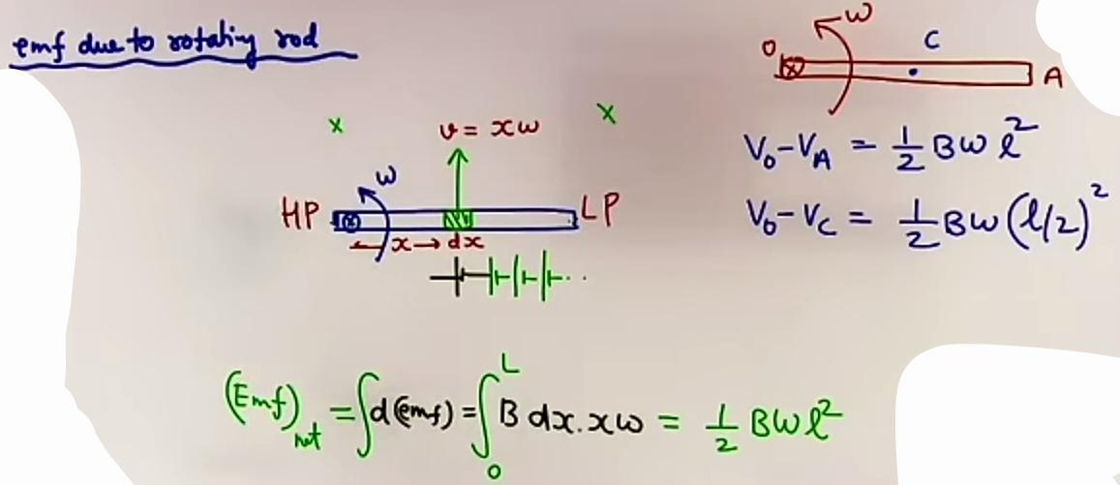

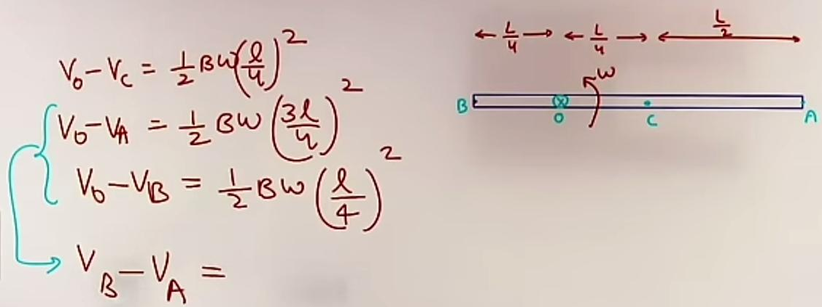
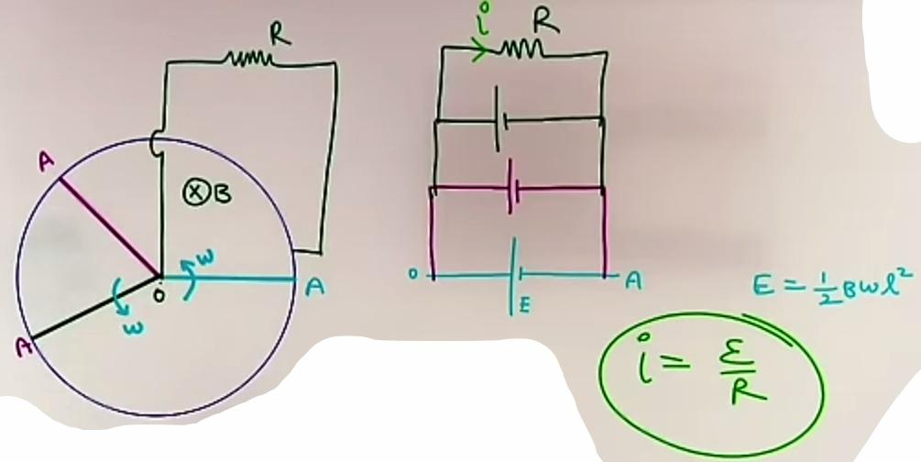
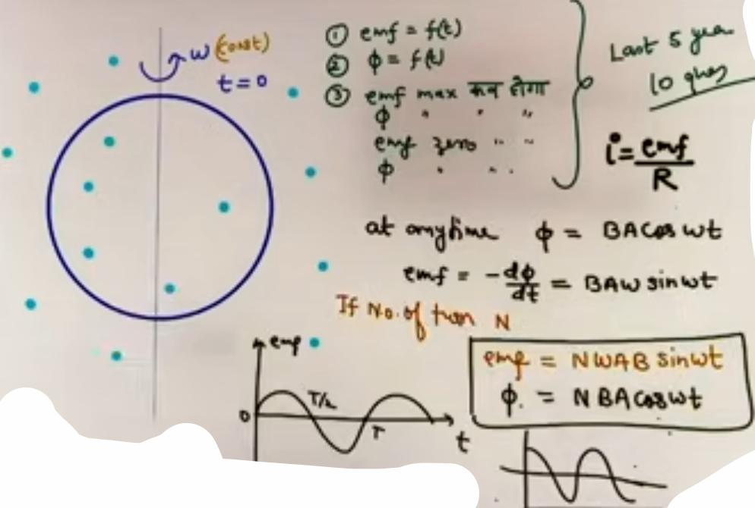
INTUITION AND CONCEPTUAL UNDERSTANDING
MENTAL MODEL: THE MOVING BATTERY
Visualize a moving rod as a physical battery. The magnitude of its voltage is BvL. To find the positive terminal, use the right-hand rule: fingers point toward B, thumb toward v, and the palm points toward the high-potential (positive) end.

TERMINAL VELOCITY ANALOGY
Think of a rod on rails like a sky譬diver. Gravity pulls it down, but "magnetic drag" (proportional to velocity) pushes back. Eventually, the drag equals gravity, and the speed becomes constant.

FORMULA SHEET
FORMULA | CONDITION | NOTES
e = BvL | v,B,L mutually perpendicular | Translational EMF
e = B⋅(v x L) | General vector form | Used for non-perpendicular cases
e = 1/2 B ω L² | Rotation about one end | Rotational EMF
e = NAB ω sin(ω t) | Rotating coil | Nawab Formula
F = B²L²v / R | Rod on rails | Retarding magnetic force
v_terminal = mgR/(B²L²) | Rod falling under gravity | Terminal velocity
ϕ = LI | General Inductance | Self-flux definition
e = -L(dI/dt) | Inductor EMF | Back EMF formula

CONCEPT CONNECTIONS
MECHANICS AND ENERGY CONSERVATION
Power supplied by an external force (P = Fv) or gravity (P = mgv) is converted into electrical power (P = ei), which is finally dissipated as heat (P = i²R) in the resistor.

JEE ADVANCED INSIGHTS
EXPONENTIAL VELOCITY DECAY
If a rod on rails is given an initial velocity v₀ and then released, the retarding force F = (B²L²v)/R causes acceleration a = -kv.
This results in velocity decreasing exponentially: v = v₀ e⁻⁽ᵏᵗ⁾.
COMMON MISTAKES AND TRAPS
MISTAKE | WHY STUDENTS MAKE IT | CORRECT APPROACH
Using Arc Length | Calculating EMF for curved wires | Use displacement length (Leff) for uniform fields.
Polarity Error | Placing the battery terminals wrong | Use (v x B) to find the high-potential end.
Neglecting R_rod | Calculating current i = e/R_ext | Total resistance is R_ext + R_rod.
Confusion on ω | Using ω for translational motion | ω is only for rotational motion (v = x ω)

HIGH-YIELD REVISION SHEET
MUST REMEMBER
- Translational EMF: e = BvL (The "BvL" Rule).
- Rotational EMF: e = 1/2 B ω L².
- Terminal Velocity: mg = B²L²v / R.
- Leff: Only endpoints matter in uniform fields.
- Direction: v x B gives the positive terminal.

LAST-MINUTE REVISION POINTS
- Nawab formula (NAB ω sin ω t) is the basis for AC generators.
- In a rotating rod, potential difference between two points x₁ and x₂ is :-
1/2 B ω (x₂² - x₁²).
- Energy stored in an inductor is 1/2 LI².
- At t=0, an inductor resists change and acts as an open circuit (broken wire).
- At t=infinity, an inductor acts as a simple conducting wire (short circuit).

--------------------------------------------------------------------------------

INTRODUCTION TO INDUCTANCE
Inductance is the property of a circuit to oppose changes in current.

SELF INDUCTANCE (L)
- Self inductance is the property of a coil by which it opposes any change in the current flowing through it by inducing an EMF in itself.
- When current (I) flows through a solenoid, it creates a magnetic field (B = μ₀nI).
- This field produces a magnetic flux (Φ) through the coil's own turns. This is called Self Flux.
- The total flux linkage is proportional to the current: Φ_total = LI.
- Self Inductance of a Solenoid:
L = (Total Flux)/I = (N * B * A)/I = (N * μ₀ * (N/l) * I * A)/I
Final Formula: L = μ₀n²Al where n = N/l (turns per unit length).
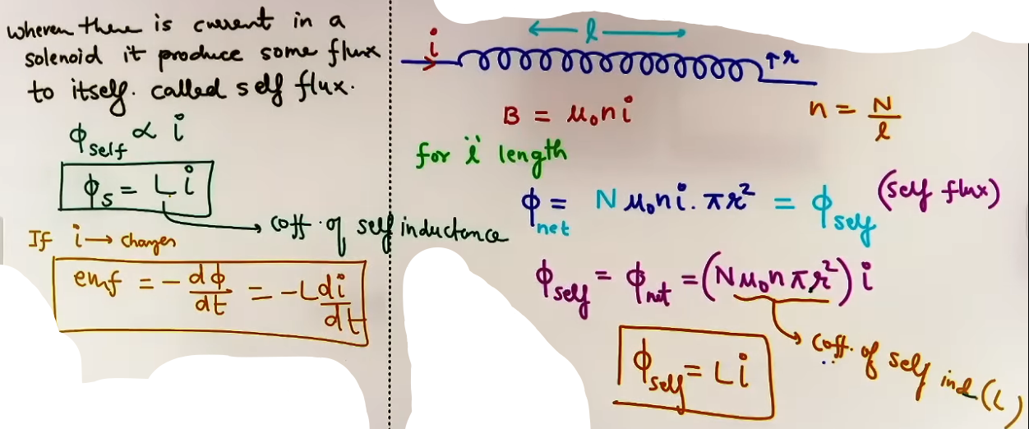
- If the current changes, an EMF is induced: e = -L(dI/dt).
# matlab solenoid khud ek battery ki tarah kaam karega aur apne through pass hone wale flux of kam karega aur current ko bhi, apni lanka khud lagayega!
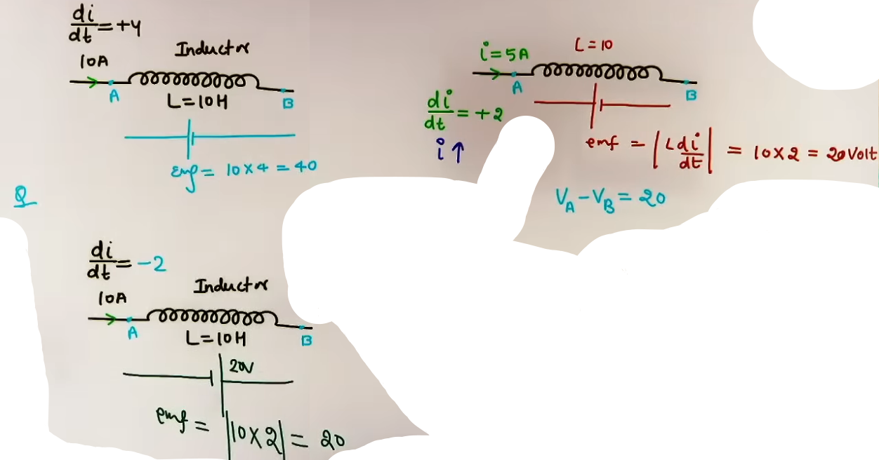
MUTUAL INDUCTANCE (M)
- Mutual inductance occurs when a change in current in one coil (Primary) induces an EMF in a nearby second coil (Secondary).
- The flux in the secondary coil is proportional to the current in the primary:
Φ₂ = MI₁.
- Induced EMF in secondary: e₂ = -M(dI₁/dt).
- Reciprocity Theorem: The mutual inductance of coil 1 with respect to coil 2 is the same as coil 2 with respect to coil 1 (M₁₂ = M₂₁).
# M is the coeff. of mutual inductance.
# kisko primary aur kisko secondary manna h ye apne vivek se karna hoga, vaise toh farak nahi padega kyunki M₁₂ = M₂₁.
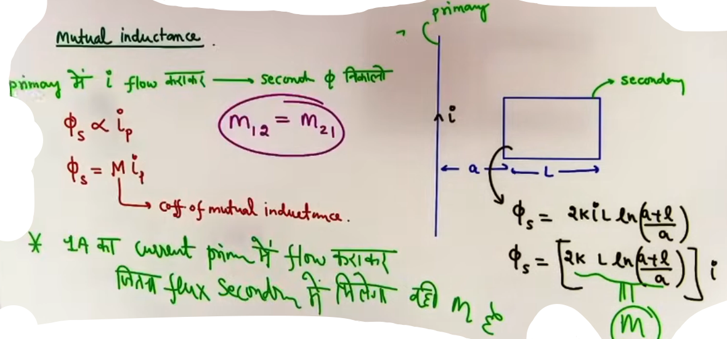
ENERGY STORAGE
An inductor stores energy in its magnetic field when current flows through it.
Magnetic Potential Energy: U = ½LI².
This is analogous to the energy stored in a capacitor (½CV²) but in the form of a magnetic field instead of an electric field.

INTUITION AND CONCEPTUAL UNDERSTANDING
THE "MAGNETIC INERTIA" MODEL
- Inductance is the electrical equivalent of mass or inertia. Just as mass resists changes in motion, inductance resists changes in current.
- An inductor does not oppose current itself; it only opposes the CHANGE in current.
FORMULA SHEET
+---------------------+----------------------+--------------------------------+
| QUANTITY | FORMULA | NOTES |
+---------------------+----------------------+--------------------------------+
| Self Flux | Φ = LI | Linkage in same coil |
| Mutual Flux | Φ₂ = MI₁ | Linkage in second coil |
| Induced EMF (Self) | e = -L(dI/dt) | Back EMF |
| Induced EMF (Mutual)| e₂ = -M(dI₁/dt) | Induced in secondary |
| Solenoid Inductance | L = μ₀n²Al | n = N/l |
| Energy Stored | U = ½LI² | Magnetic energy |
| Series (No M) | L_eq = L₁ + L₂ | Simple addition |
| Series (With M) | L_eq = L₁ + L₂ ± 2M | +for same sense, -for opposite |
| Parallel (No M) | 1/L_eq = 1/L₁ + 1/L₂ | Reciprocal addition |
+---------------------+----------------------+--------------------------------+
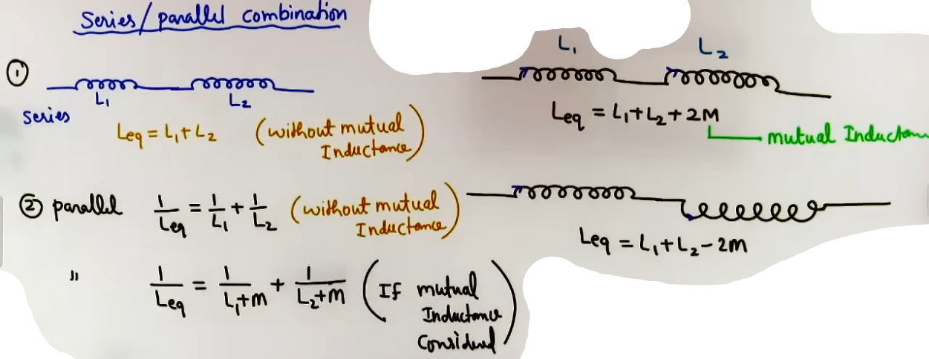
CONCEPT CONNECTIONS

INDUCTOR VS. CAPACITOR
- Inductors (L) store magnetic energy (½LI²); Capacitors (C) store electric energy (½CV²).
- At t=0, an inductor behaves like an open circuit (resists change); a capacitor behaves like a short circuit.
- At t=infinity, an inductor behaves like a short circuit (simple wire); a capacitor behaves like an open circuit.

LINK TO MAGNETISM
Inductance formulas depend purely on the geometry (N, A, l) and the medium (μ₀), similar to how capacitance depends on geometry (A, d) and medium (ε₀).

HIGH-YIELD REVISION SHEET

MUST REMEMBER:
- Self Inductance: Φ = LI; e = -L(dI/dt).
- Solenoid L: μ₀n²Al or μ₀N²A/l.
- Mutual Inductance: M = Φ₂/I₁.
- Energy: U = ½LI².
- Series L with M: L₁ + L₂ ± 2M.

LAST-MINUTE REVISION POINTS:
- M for concentric loops (R >> r): M is proportional to r²/R.
- If a coil is wound on a soft iron core, L increases by a factor of μᵣ (Relative Permeability).
- Induced EMF exists as long as current is changing. If I is constant, e = 0.
- In RL circuits, the time constant τ = L/R represents how fast current reaches steady state.

--------------------------------------------------------------------------------
ORIGIN OF INDUCED ELECTRIC FIELDS {least important}
- In the experiment where a stationary electron is placed in a cylindrical region of magnetic field, the electron is observed to move when the magnetic field magnitude (B) is changed.
- Magnetic fields only exert force on moving charges (F = qvB). Since the electron was stationary (v = 0), a magnetic field cannot be responsible for its initial motion.
- Gravity and other forces are also ruled out. The only force that can move a stationary charge is an electric field (F = qE).
- Therefore, a time-varying magnetic field (dB/dt) produces an electric field in its surroundings.

GENERAL PROPERTIES
Induced electric fields (E_in) are fundamentally different from the electrostatic fields (Ec) studied in electrostatics.
1. Non-conservative Nature: The work done by an induced electric field in moving a charge around a closed path is non-zero.
2. Closed Loops: Unlike electrostatic fields that originate from positive charges and terminate on negative charges, induced electric fields form continuous closed loops.
3. Absence of Source Charges: These fields exist in space even if there are no charges or conductors present. They are a property of the space where the magnetic field is changing.
4. Direction: The direction is given by Lenz's Law. If you place a conducting loop in the region, the induced electric field will be tangential to the loop and in the direction of the induced current.

MATHEMATICAL DEFINITION
- The line integral of the induced electric field around a closed loop is equal to the rate of change of magnetic flux through that loop.
∫(E⋅dl) = -dϕ/dt
- For a circular path of radius r centered on a cylindrical magnetic field region:
E*(2πr) = Area*(dB/dt)
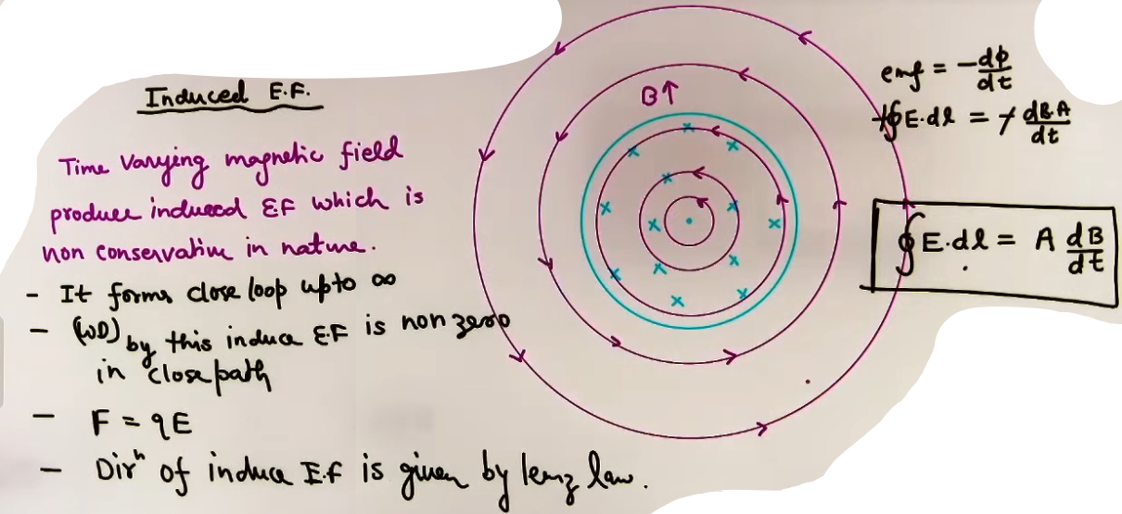
INTUITION AND CONCEPTUAL UNDERSTANDING

THE SWIRL ANALOGY
Imagine the changing magnetic field as a source that "stirs" the space around it. This stirring creates circular "swirls" or vortices of electric field lines.

DIFFERENCE FROM ELECTROSTATIC E-FIELD
Electrostatic E-field = A "hill" or "slope" where potential is defined.
Induced E-field = A "whirlpool" where potential cannot be defined because coming back to the start point adds more energy.
FORMULA SHEET
FOR A CYLINDRICAL REGION OF RADIUS R:
The magnetic field B exists only for r < R. Let the rate of change be dB/dt.
+------------+------------------+---------------------+------------------------+
| CASE | RADIUS CONDITION | MAGNITUDE OF E | RELATION |
+------------+------------------+---------------------+------------------------+
| Inside | r < R | E = (r/2)*(dB/dt) | E proportional to r |
| Outside | r > R | E = (R²/2r)*(dB/dt) | E proportional to 1/r |
| On Surface | r = R | E = (R/2)*(dB/dt) | Maximum value |
+------------+------------------+---------------------+------------------------+
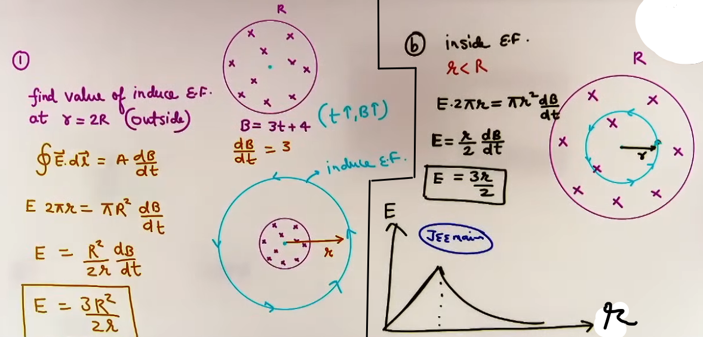
Conditions:
- These formulas assume a cylindrical symmetry for the magnetic field region.
- dB/dt must be uniform across the cross-section for the "Inside" formula.

CONCEPT CONNECTIONS

LINK TO MAXWELL'S EQUATIONS
This is the third Maxwell equation. It explains how electricity and magnetism are unified.

LINK TO EM WAVES
Induced electric fields are the mechanism by which electromagnetic waves propagate through a vacuum.

LINK TO LENZ'S LAW
The "swirl" direction of the E-field is exactly the direction a current would flow if a wire were placed there.

PROBLEM-SOLVING FRAMEWORK

QUESTION TYPE | IDENTIFICATION CLUE | APPROACH / STRATEGY
Find E at r < R | "Inside the region" | Use E = (r/2)(dB/dt).
Find E at r > R | "Outside the region" | Use E = (R²/2r)(dB/dt).
EMF on a Line | "Line passing through center" | EMF = 0 if the line is a radius.
EMF on a Segment | "Segment forming a triangle" | Use EMF = (Area of triangle) * (dB/dt).

JEE ADVANCED INSIGHTS

THE NON-EXISTENCE OF POTENTIAL
Because the field is non-conservative, the concept of "Electric Potential" (V) does not exist for induced electric fields. You cannot say point A is at 5V and point B is at 2V based solely on this field.

EMF ON CHORDS
While EMF is zero along a radius, it is NOT zero along a chord (a line not passing through the center).
To find EMF along a chord AB:
EMF_AB = (Area of triangle formed by O, A, and B) * (dB/dt).

HIGH-YIELD REVISION SHEET
MUST REMEMBER
- Inside E: (r/2)(dB/dt).
- Outside E: (R²/2r)(dB/dt).
- Properties: Non-conservative, closed loops, exists in vacuum.
- Direction: Tangential to circles, follows Lenz's Law.

GRAPH OF E VS r:
- Straight line from r=0 to r=R (slope = 0.5 * dB/dt).
- Hyperbolic curve (1/r) for r > R.

LAST-MINUTE REVISION POINTS
- If dB/dt is constant, E is constant at a fixed point.
- If dB/dt is zero, E is zero (static fields don't induce E-fields).
- If a charge moves in a closed circle of radius r, work done is (q * E * 2πr) = q * Area * dB/dt.
- Induced E-fields are tangential; they cannot have a radial component in a cylindrical setup.

--------------------------------------------------------------------------------
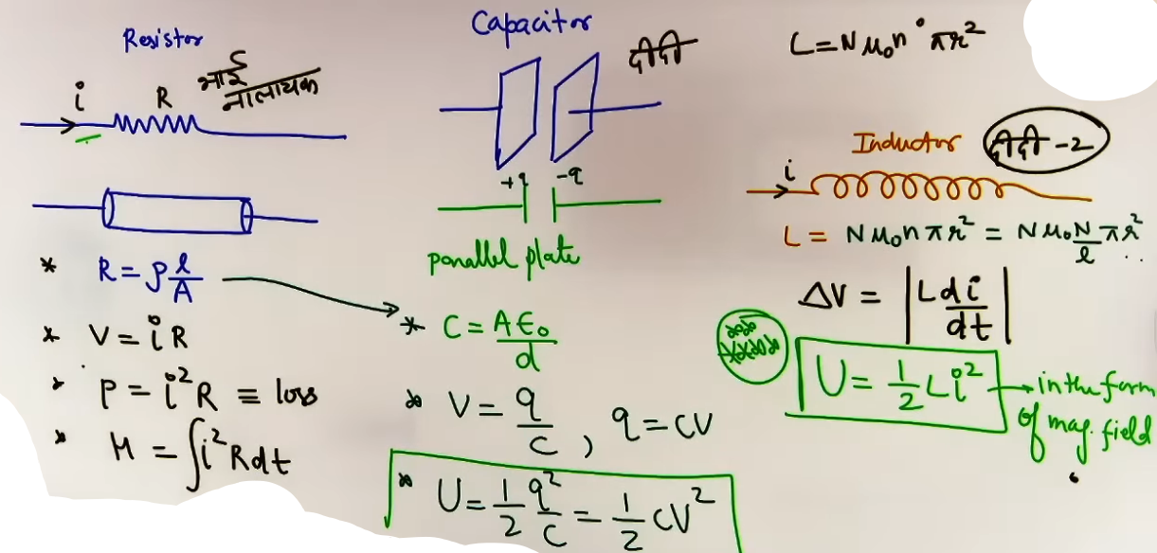

RL CIRCUITS
- An RL circuit consists of a resistor (R) and an inductor (L) connected to a voltage source. The inductor introduces magnetic inertia into the circuit, resisting any sudden changes in the flow of current.
- Unlike a purely resistive circuit where current reaches its maximum value instantly, in an RL circuit, the current grows or decays exponentially over time.

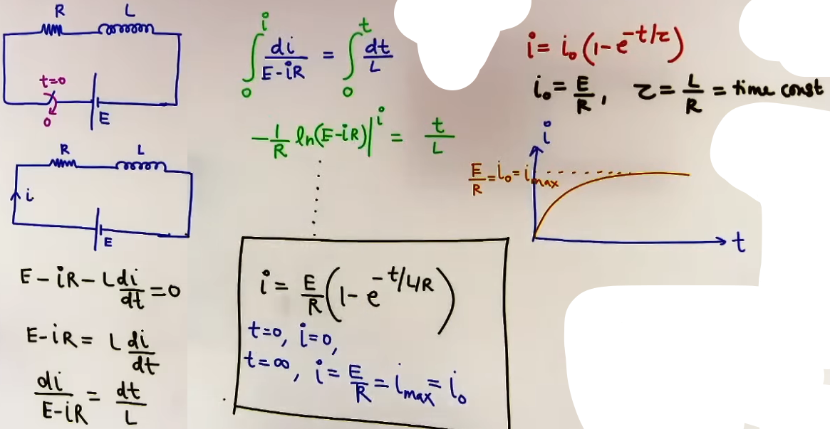
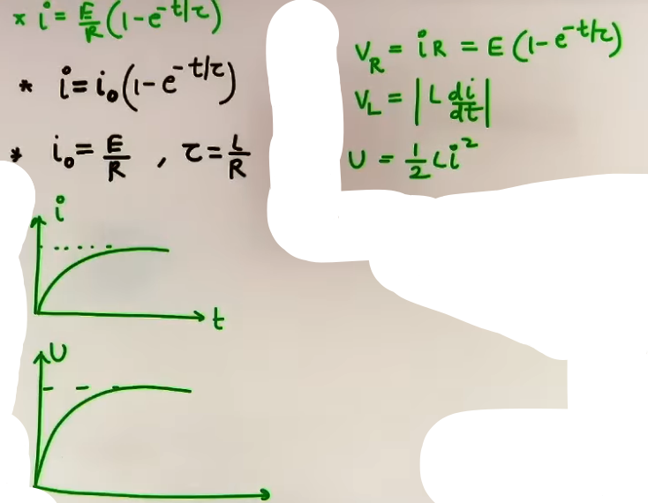
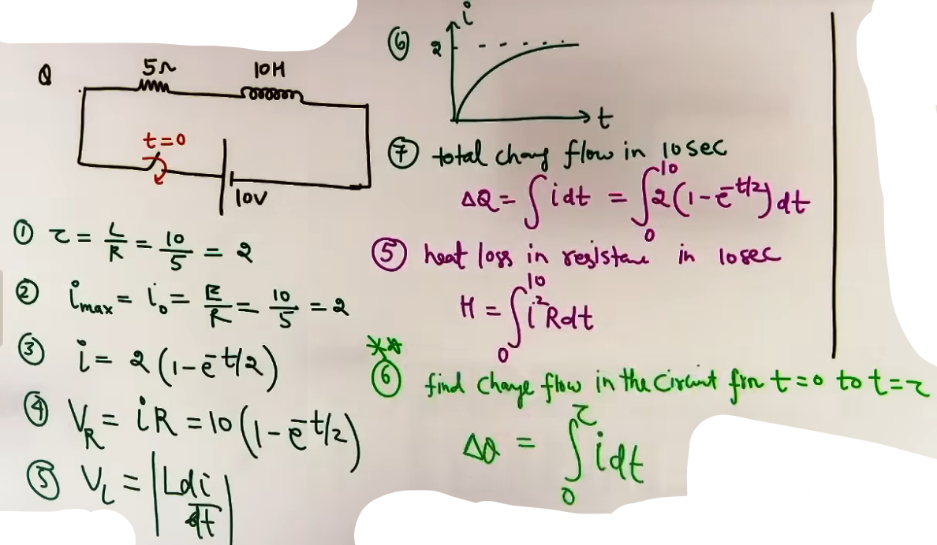
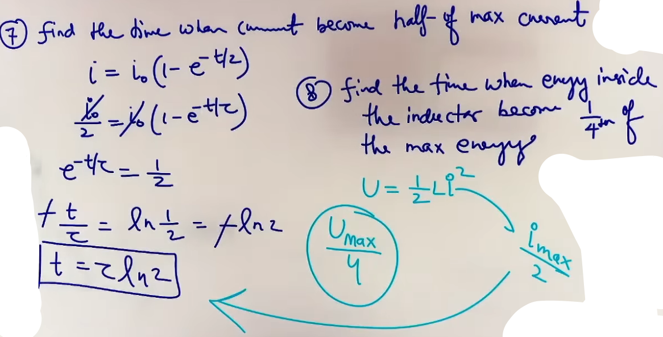
Sare main formulae

GROWTH OF CURRENT
- When the switch in an RL circuit is closed at t = 0, the inductor opposes the rise of current by producing a back EMF (e = -L di/dt).
- The current starts from zero and gradually approaches its maximum steady-state value (i₀).
- Steady-state current is reached when the rate of change of current (di/dt) becomes zero, meaning the inductor no longer opposes the flow.

DECAY OF CURRENT
- When a battery is removed from an RL circuit and the circuit is shorted, the magnetic field in the inductor begins to collapse.
- The inductor now acts as a source, attempting to maintain the existing current by producing an induced EMF in the same direction as the original current.
- The current starts at its initial maximum value (i₀) and decays exponentially toward zero.
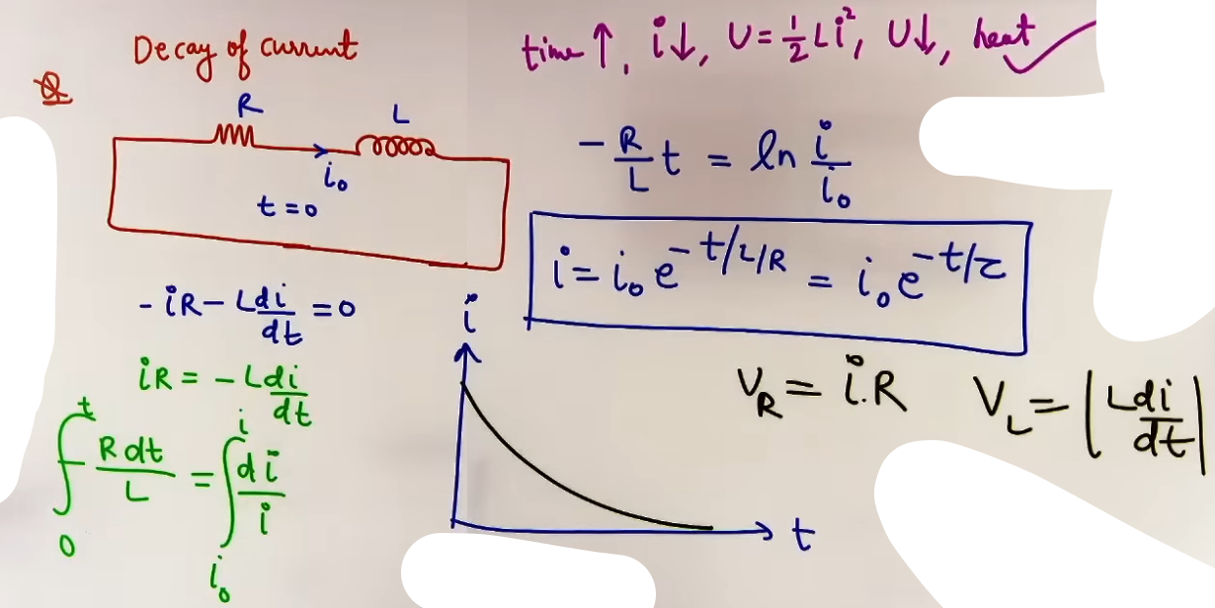
INTUITION AND CONCEPTUAL UNDERSTANDING

THE MASS-INERTIA ANALOGY
- Think of the inductor (L) as mass and the current (i) as velocity.
- Just as a heavy object cannot reach full speed instantly due to inertia, current in an inductor cannot jump from 0 to i₀ instantly.
- Similarly, a heavy moving object cannot stop instantly; the inductor keeps the current flowing for a while even after the "push" (battery) is removed.

THE RESISTANCE TO CHANGE
- An inductor does not hate current; it hates the CHANGE in current.
- At the moment you turn a switch on (t = 0), the change is infinite, so the inductor fights back with maximum effort, effectively breaking the circuit.
- After a long time (t = infinity), the current is stable, so the inductor has nothing to fight and behaves like an ordinary wire.

FORMULA SHEET
+----------------------+---------------------+--------------------------------+
| QUANTITY | FORMULA | NOTES |
+----------------------+---------------------+--------------------------------+
| Steady State Current | i₀ = E / R | Current at t = infinity |
| Time Constant | τ = L / R | Units are seconds (s) |
| Growth of Current | i = i₀(1 - e⁻ᵗ/ᵗᵃᵘ) | t is time after closing switch |
| Decay of Current | i = i₀(e⁻ᵗ/ᵗᵃᵘ) | i₀ is initial current at t = 0 |
| Inductor Potential | V = L (di/dt) | Potential drop across inductor |
| Energy Stored | U = 1/2 L i² | Stored in magnetic field |
+----------------------+---------------------+--------------------------------+
CONCEPT CONNECTIONS
INDUCTORS VS CAPACITORS
Inductors are the "mirror image" of capacitors regarding transient behavior.
+--------------+-----------------------------+-----------------------------+
| TIME | INDUCTOR BEHAVIOR | CAPACITOR BEHAVIOR |
+--------------+-----------------------------+-----------------------------+
| t = 0 | Open Circuit (Broken wire) | Short Circuit (Simple wire) |
| t = infinity | Short Circuit (Simple wire) | Open Circuit (Broken wire) |
+--------------+-----------------------------+-----------------------------+

ENERGY DISSIPATION
- During current growth, the battery supplies energy. Some is stored in the inductor's magnetic field (1/2 L i²), and some is lost as heat in the resistor (i²R).
- During current decay, the energy stored in the inductor is entirely dissipated as heat in the resistor as the current goes to zero.

JEE ADVANCED INSIGHTS

THE VOLTAGE JUMP
- While current through an inductor cannot change instantaneously, the voltage across an inductor CAN change instantly.
- At t = 0, the inductor voltage jumps from 0 to the full battery voltage to oppose the current start.

EXPONENTIAL RELATIONS
The value of e⁻¹ is approximately 0.37.
In one time constant (t = tau):
- During growth, current reaches 63 percent of its maximum value.
- During decay, current drops to 37 percent of its initial value.

HIGH-YIELD REVISION SHEET
MUST REMEMBER
Formula for Growth: i = i₀(1 - exp(-t / tau)).
Formula for Decay: i = i₀(exp(-t / tau)).
Time Constant: tau = L / R.
t = 0 state: Inductor = Open Circuit.
t = infinity state: Inductor = Short Circuit.

LAST-MINUTE REVISION POINTS
- The inductor opposes the RATE of change (di/dt), not the current (i) itself.
- Energy is stored in the magnetic field (U = 1/2 L i²).
- If there are multiple resistors, R in the tau formula is the Thevenin equivalent resistance as seen by the inductor.
- To find the time when current is half of maximum, use t = tau ln(2).

--------------------------------------------------------------------------------

EDDY CURRENTS {not so imp}

- Eddy currents are loops of electrical current induced within solid conductors by a changing magnetic field in the conductor, according to Faraday's law of induction.
- Unlike currents in a thin wire which are restricted to a specific path, eddy currents flow in closed loops within the bulk of the material, similar to eddies or whirlpools in a fluid.

MECHANISM OF GENERATION
- When a solid metallic plate or block moves into or out of a magnetic field, the magnetic flux (ϕᵦ) linked with the plate changes.
- As per Faraday's Law (e = -dϕᵦ/dt), an EMF is induced.
- Since the metal plate provides a low-resistance path, currents are generated that circulate within the body of the plate.
DAMPING AND ENERGY TRANSFORMATION
- The induced eddy currents produce their own magnetic fields that oppose the change that created them (Lenz's Law).
- This opposition manifests as a mechanical braking force, known as Magnetic Damping.
- The kinetic energy of the moving plate is converted into thermal energy (Heat) due to the resistance of the metal.
- Power Dissipation: P = I²R, where I is the eddy current and R is the resistance of the path.

CONDITIONS FOR MINIMIZING EDDY CURRENTS:
1. Use of laminated cores (thin sheets separated by insulation).
2. Creating slots in the metal plate to break the large circulating loops.

CONCEPT CONNECTIONS

LINK TO THERMODYNAMICS
Eddy currents provide a way to convert mechanical work directly into heat without friction. This is used in Induction Furnaces to melt metals.

LINK TO LENZ'S LAW
The "opposition to motion" is a direct application of Lenz's Law. If the currents supported the motion, the plate would accelerate indefinitely, violating the Law of Conservation of Energy.

EXAMPLES AND APPLICATIONS

EXAMPLE 1: THE OSCILLATING METALLIC PLATE
A solid metal plate swinging like a pendulum between the poles of a magnet stops almost instantly.
Reason: Rapidly changing flux induces massive eddy currents and strong damping.
Improvement: If slots are cut into the plate (making it look like a comb), the damping is greatly reduced because the large current loops are broken.

EXAMPLE 2: MAGNETIC BRAKING IN TRAINS
Electromagnets are placed near the rails. When activated, the changing flux in the rails induces eddy currents that create a force opposing the train's motion.
Benefit: No mechanical wear and tear as there is no physical contact.

EXAMPLE 3: DEADBEAT GALVANOMETER
The coil is wound on a metallic frame. When the coil oscillates, eddy currents in the frame damp the motion, allowing the needle to settle at its final position quickly without vibrating.

HIGH-YIELD REVISION SHEET
MUST REMEMBER:
- Eddy currents occur in bulk metallic pieces, not just wires.
- They follow Lenz's Law (oppose motion/flux change).
- They cause energy loss as heat (P = I²R).
- Lamination/Slotting is the standard way to reduce them.

SUMMARY OF PLATE MOTION IN B-FIELD:
PLATE TYPE | DAMPING LEVEL | REASON
Solid Metal | High | Large loops, low resistance, high I.
Slotted Metal | Low | Small loops, high resistance path, low I.
Plastic/Wood | Zero | No free electrons to form current.

LAST-MINUTE REVISION POINTS:
- Eddy currents are also called Foucault Currents.
- In a transformer, eddy currents are "waste" energy.
- In an induction furnace, eddy currents are "useful" energy.
- Use the Right-Hand Rule to find the direction of the "whirlpool" just like you would for a wire loop.

